25OJ401
An Internship report submitted by

GARSWEL ROSHAN A M - Reg.No URK25CS7029
in partial fulfillment for the award of the degree of

BACHELOR OF TECHNOLOGY
in

COMPUTER SCIENCE AND ENGINEERING (ARTIFICIAL INTELLIGENCE / ARTIFICIAL INTELLIGENCE AND
MACHINE LEARNING)

under the supervision of

Mr. Nanthagopal /ASSISTANT PROFESSOR



DIVISION OF ARTIFICIAL INTELLIGENCE AND MACHINE LEARNING
SCHOOL OF COMPUTER SCIENCE AND TECHNOLOGY
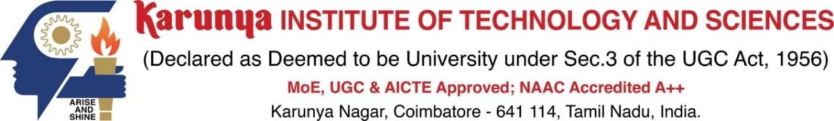

September 2026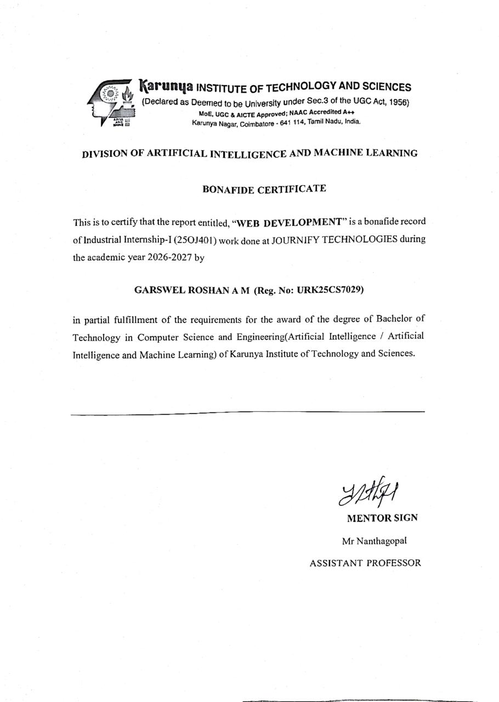

ACKNOWLEDGEMENT

First and foremost, I praise and thank ALMIGHTY GOD whose blessings have bestowed in me the will power and confidence to carry out my Internship.
I am grateful to our beloved founders Late. Dr. D.G.S. Dhinakaran, C.A.I.I.B, Ph.D and Dr. Paul Dhinakaran, M.B.A, Ph.D, for their love and always remembering us in their prayers.
I extend my thanks to Dr. R. Elijah Blessing, Ph.D., our honorable Vice Chancellor, and Dr. S. J. Vijay, Ph.D., our respected Registrar for giving me this opportunity to do the internship.
I would like to place my heart-felt thanks and gratitude to Dr. D. Sujitha Juliet, M.E., Ph.D., Head of the Division, Artificial Intelligence and Machine Learning for her encouragement and guidance.
I feel it a pleasure to be indebted to, Mr. Nanthagopal for the invaluable support, advice and encouragement.
I also thank all the staff members of the Division for extending their helping hands to make this in Internship a successful one.
I would also like to thank all my friends and my parents who have prayed and helped me during the Internship.

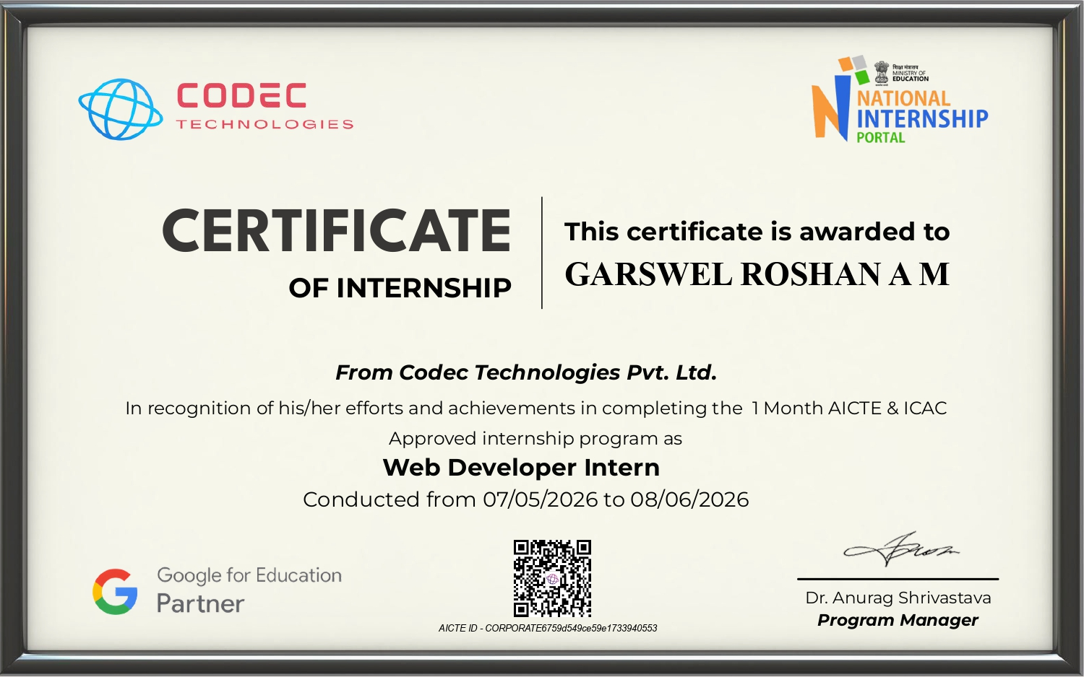

TABLE OF CONTENTS

S.No. | Title | Page No.
1 | Introduction | 8
2 | Overview | 8
3 | Objective | 9
4 | System Design | 9
5 | Implementation | 11
6 | Screenshots of Implementation | 14
7 | Summary | 17

- INTRODUCTION

CampusHire is a comprehensive, AI-driven Placement Intelligence Platform designed to modernize the campus recruitment ecosystem. Built as a unified web application, it bridges the gap between students, recruiters, and placement officers by transforming fragmented hiring processes into a seamless, data-driven experience.
The platform features three tailored portals. For students, it offers AI-powered resume analysis, skill gap identification, and smart job matching to enhance employability. Recruiters benefit from streamlined applicant tracking, automated eligibility checks, and digital offer letter generation. Meanwhile, placement officers gain macro-level oversight through real-time placement analytics and a dedicated Diversity & Inclusion (D&I) dashboard to ensure equitable hiring practices.
Developed using modern web technologies including HTML5, CSS3, Vanilla JavaScript, and Chart.js, CampusHire leverages local storage for persistent data management. By integrating intelligent algorithms for job-matching and automated workflows, the platform significantly reduces administrative overhead while empowering students with actionable career guidance. Ultimately, CampusHire aligns institutional placement goals with modern corporate standards, fostering a transparent, efficient, and inclusive recruitment lifecycle.

2.OVERVIEW:
The CampusHire Placement Intelligence Platform is a comprehensive, role-based web application designed to digitize and optimize the campus recruitment lifecycle. Built using modern frontend technologies (HTML5, CSS3, Vanilla JavaScript, and Chart.js) with LocalStorage for data persistence, the platform serves three primary user personas: Students, Recruiters, and Placement Officers.
For students, it offers an AI-driven dashboard featuring smart job matching, an automated Resume Analyzer, Skill Gap Analysis, and an interactive AI Career Assistant. Recruiters are equipped with tools to post jobs, manage applicant pipelines, schedule interviews, and generate digital offer letters with signature support. Meanwhile, the Admin portal provides macro-level oversight through real-time placement statistics, branch-wise analytics, and a dedicated Diversity & Inclusion (D&I) dashboard. By integrating intelligent algorithms for eligibility verification and profile scoring, CampusHire transforms fragmented placement processes into a seamless, transparent, and data-driven ecosystem.

3. OBJECTIVE
The primary objectives of the CampusHire project are:
Enhance Student Employability: To provide students with AI-powered tools, including resume scoring, personalized job recommendations, and skill gap analysis, to maximize their placement readiness.
Streamline Recruiter Workflows: To offer recruiters an intuitive interface for posting roles, filtering candidates via automated eligibility checks, managing interview schedules, and issuing digital offer letters.
Empower Administrative Oversight: To equip placement officers with real-time analytics, comprehensive placement statistics, and a Diversity & Inclusion (D&I) tracking module to monitor gender and regional representation for equitable hiring.
Automate Core Processes: To significantly reduce manual administrative overhead by automating eligibility verification, application pipeline tracking, and offer letter generation.
Deliver Intelligent Career Guidance: To integrate an interactive AI Career Assistant chatbot that provides students with real-time, personalized advice on resume optimization, interview preparation, and career planning.

SYSTEM DESIGN :

1.1 Architecture Overview
CampusHire is a client-side Single Page Application (SPA) built with vanilla JavaScript, HTML5, and CSS3. It utilizes a three-tier role-based architecture serving Students, Recruiters, and Placement Officers (Admin).
1.2 System Components
Frontend Layer: Responsive UI using CSS Grid/Flexbox, Chart.js for analytics dashboards, and dynamic modal/toast interactions.
Data Layer: Browser-based persistence via localStorage using structured JSON models and pre-populated seed data for demonstration.
Business Logic: Features an automated Eligibility Engine, a multi-factor Job Matching Algorithm, an 8-metric ATS Resume Analyzer, and a Skill Gap Analyzer.
1.3 Database Schema Design
The system manages eight core JSON entities: Users (Auth/Roles), Students (Academics/Skills), Companies (Culture/D&I), Jobs (Eligibility/CTC), Applications (Status tracking), Interviews (Scheduling), Offer Letters (Compensation/Signatures), and Notifications.
1.4 Design Patterns
The codebase utilizes the Module Pattern for role encapsulation, the Observer Pattern for reactive UI updates, the Factory Pattern for dynamic component generation, and centralized State Management for session handling.
1.5 Security Considerations
Data integrity and access are maintained through role-based view rendering, client-side input sanitization (XSS prevention), secure session persistence via localStorage, and password-protected authentication.

IMPLEMENTATION :

The platform was implemented as an interactive web application using Full Stack Development This section covers the implementation of the CampusHire platform, focusing on frontend development with HTML, CSS, and JavaScript, client-side data persistence with LocalStorage, and data visualization with Chart.js. The application operates as a Single Page Application (SPA) featuring dynamic UI rendering, client-side routing, and role-based access control.
Multi-role Authentication System: Secure login and registration for Students, Recruiters, and Placement Officers with session persistence.
AI-Powered Resume Analyzer: Evaluates resumes on 8 parameters (length, summary, skills, projects, etc.) and provides an ATS compatibility score.
Visual Application Tracking: A 5-stage interactive timeline (Applied → Shortlisted → Interview → Selected/Rejected) with real-time activity logs.
Interview Scheduling & Notifications: Interactive calendar for recruiters to schedule rounds, triggering automated alerts for students.
Automated Offer Letter Generation: Creates formal offer letters upon candidate selection, featuring a compensation breakdown and a digital signature canvas.
Comprehensive Company Profiles: Detailed pages showcasing company culture, benefits, employee testimonials, and office locations.
Placement Statistics Dashboard: Admin analytics featuring dynamic charts for branch-wise placements, application status splits, and CTC distributions.
AI Career Assistant Chatbot: A context-aware floating chat interface providing real-time resume tips, job recommendations, and interview preparation guidance.

SCREENSHOTS OF IMPLEMENTATION :
1. Login Page
Displays branding, platform statistics, and role-based authentication tabs with quick demo login buttons for seamless access.
2. Student Dashboard
Features personalized stats, AI-powered job recommendations with match scores, a placement readiness gauge, and upcoming interview lists.
3. Browse Jobs Page
Displays filterable job cards featuring AI match scores, eligibility badges, CTC details, and quick apply status indicators.
4. Job Detail Modal
Presents comprehensive role details, visual skill gap analysis, eligibility criteria, selection rounds, and an application countdown timer.
5. My Applications Page
Tracks application progress through a visual five-stage timeline, displaying status badges, company details, and timestamped activity logs.
6. Resume Analyzer
Evaluates resumes using an ATS score gauge, eight quality checks, a preview section, and an actionable improvement roadmap.
7. Skill Gap Analysis
Visualizes high-impact missing skills, current proficiencies, and job-wise skill matches to guide targeted learning and profile improvement.
8. Interviews Page
Lists scheduled and completed interviews in detailed cards, displaying round names, modes, venues, and feedback results.
9. Student Profile Page
Manages editable academic details, tracks profile completion, and showcases skills, projects, and certifications with progress indicators.
10. Company Profile Page
Showcases company details through tabbed sections for culture, benefits, testimonials, locations, and current open job positions.
11. Recruiter Dashboard
Provides a hiring overview with key metrics, recent job lists, and a visual pipeline breakdown of applicant stages.
12. Post a Job Form
Facilitates job creation with comprehensive fields for eligibility criteria, compensation, required skills, and selection round configurations.
13. Applicants Management Page
Filters and lists applicants in a detailed table, allowing recruiters to update statuses and trigger automated notifications.
14. Interview Scheduling Modal
Schedules interviews by capturing round details, dates, and modes, automatically updating applicant statuses and sending notifications.
15. Offer Letters Page
Displays a comprehensive table of generated offer letters, tracking candidate details, CTC breakdowns, and acceptance statuses.
16. Offer Letter Document
Generates formal employment offers detailing candidate information, comprehensive compensation breakdowns, terms, and designated signature blocks.
17. Digital Signature Canvas
Provides an interactive drawing area for candidates to capture and embed mouse or touch signatures into documents.
18. Admin Dashboard
Overviews the placement season with key metrics, company-wise job distributions, and scheduled interview timelines for administrators.
19. Placement Statistics Page
Visualizes placement metrics through summary cards, branch-wise charts, status doughnuts, and company-wise offer distributions with key insights.
20. Diversity & Inclusion Dashboard
Tracks gender, regional representation, and partner D&I metrics through visual charts and accessibility accommodation grids.
21. AI Career Assistant Chat
Delivers context-aware career guidance, resume tips, and skill gap insights through an interactive floating chat interface.
22. Responsive Mobile View
Ensures seamless mobile usability with adaptive layouts, collapsible navigation, stacked cards, and touch-friendly interface elements.

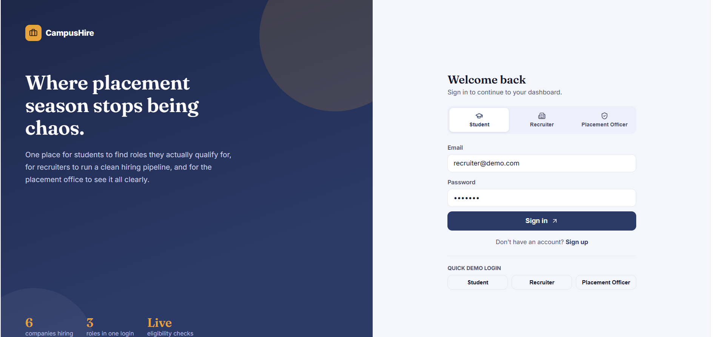

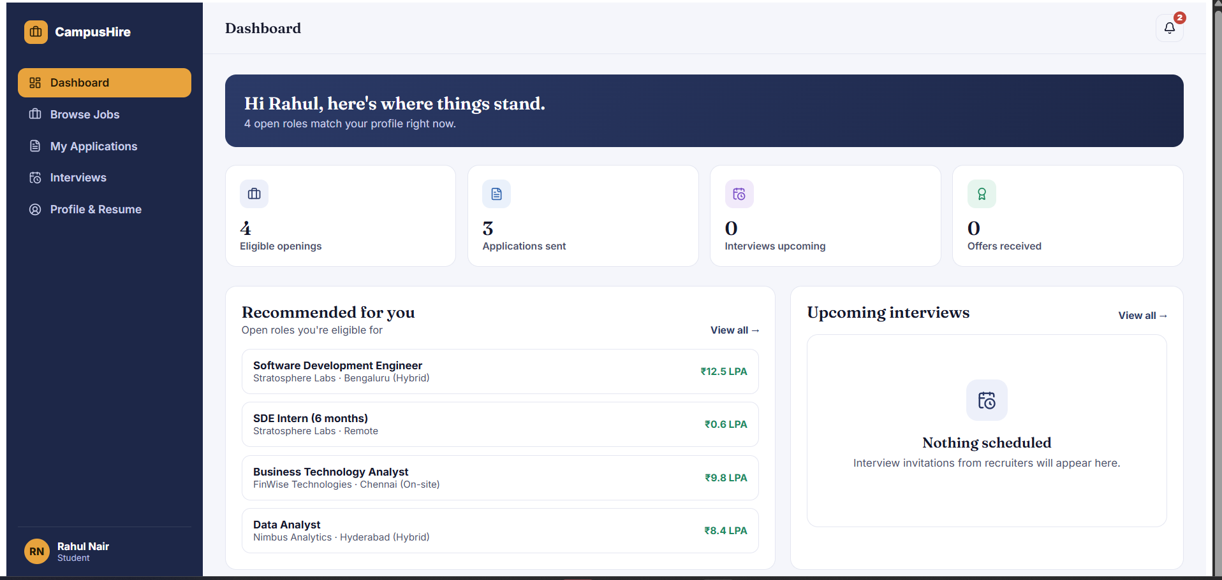

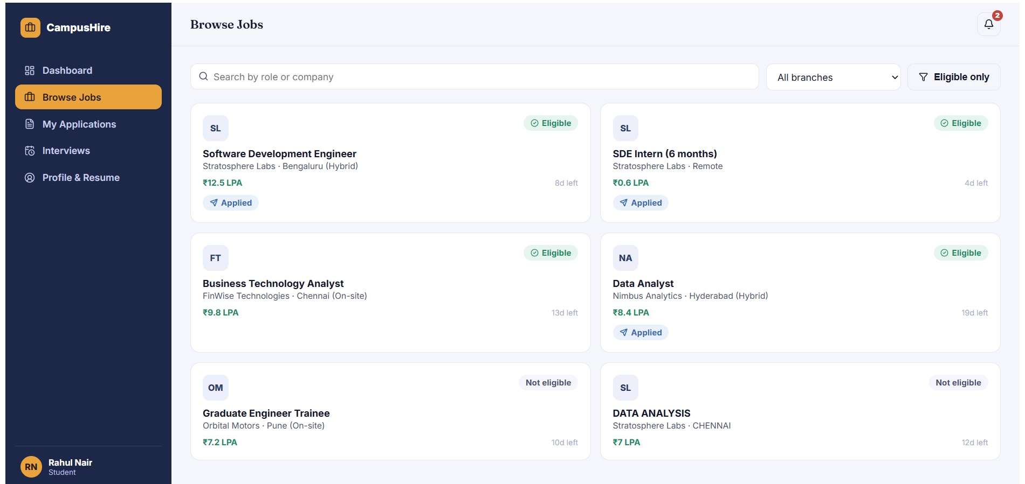

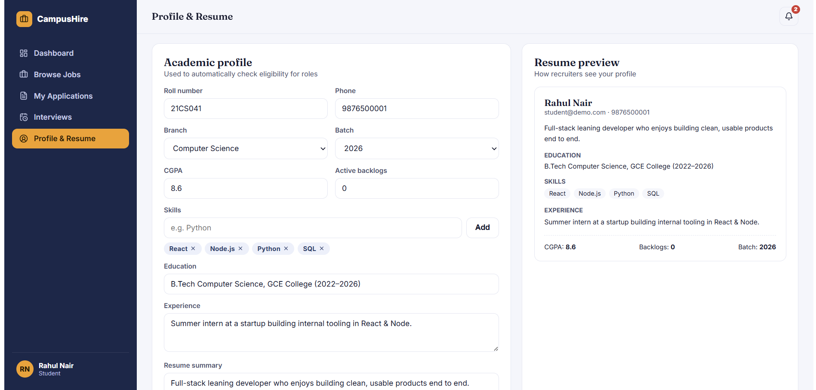

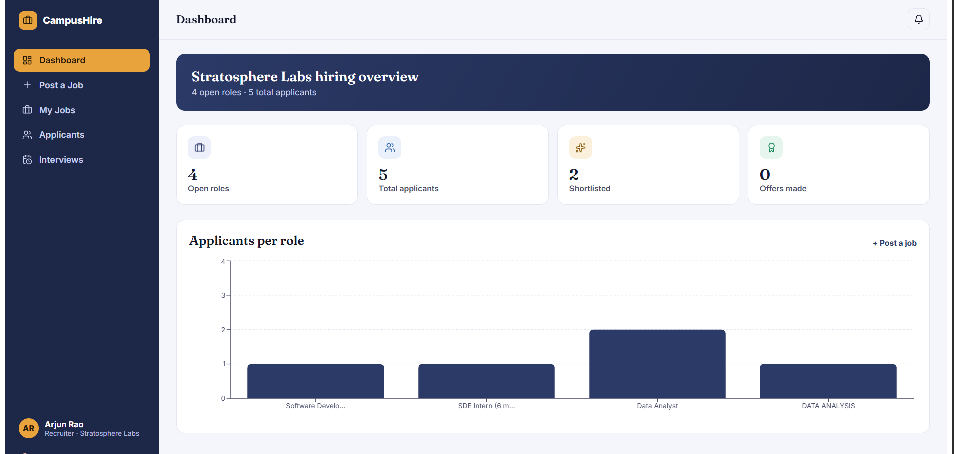

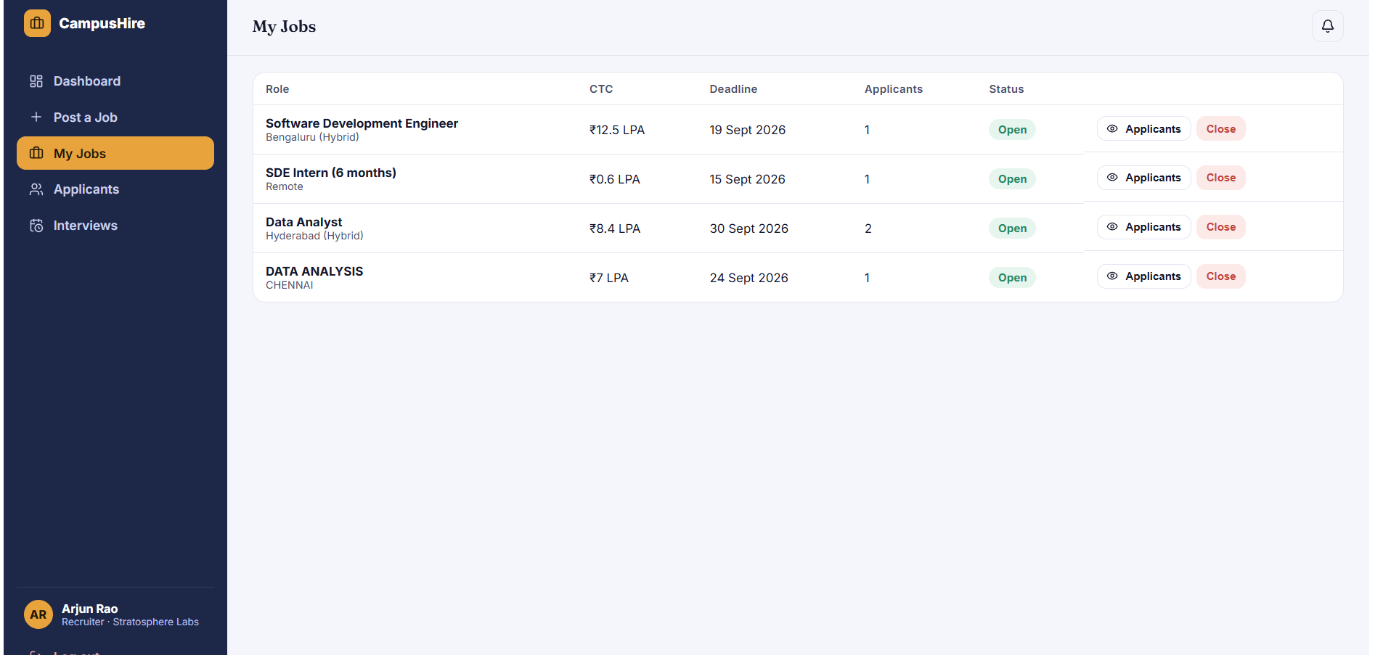

SUMMARY :
CampusHire is a Full Stack Development project focused on delivering a complete, AI-powered campus placement experience — from student registration and smart job matching through to interview scheduling, offer letter generation, and placement analytics — built entirely as a client-side Single Page Application without a backend framework or an external database service.
The project is supported by Full Stack Development skills including frontend development with HTML5, CSS3, and JavaScript (ES6+), client-side data persistence using the LocalStorage API, data visualization with Chart.js, responsive UI design, role-based access control, algorithm development for job matching and resume analysis, and end-to-end project development from authentication and dashboard design through automated offer workflows and Diversity & Inclusion tracking.

